USER GUIDE · V1.0
Trianz GTM Portal
End User Documentation

The Trianz GTM Portal is a tool that helps your team find real business leads — automatically. Instead of spending hours reading news and researching companies, the portal does it for you. It scans public business signals across trusted sources like Google News, PR Newswire, and CIO.com, picks up on signals that match your focus areas (such as specific industries, regions, or services), and presents them as ready-to-act leads on your dashboard. You set your preferences once, and the portal keeps working in the background — even when you're not logged in.
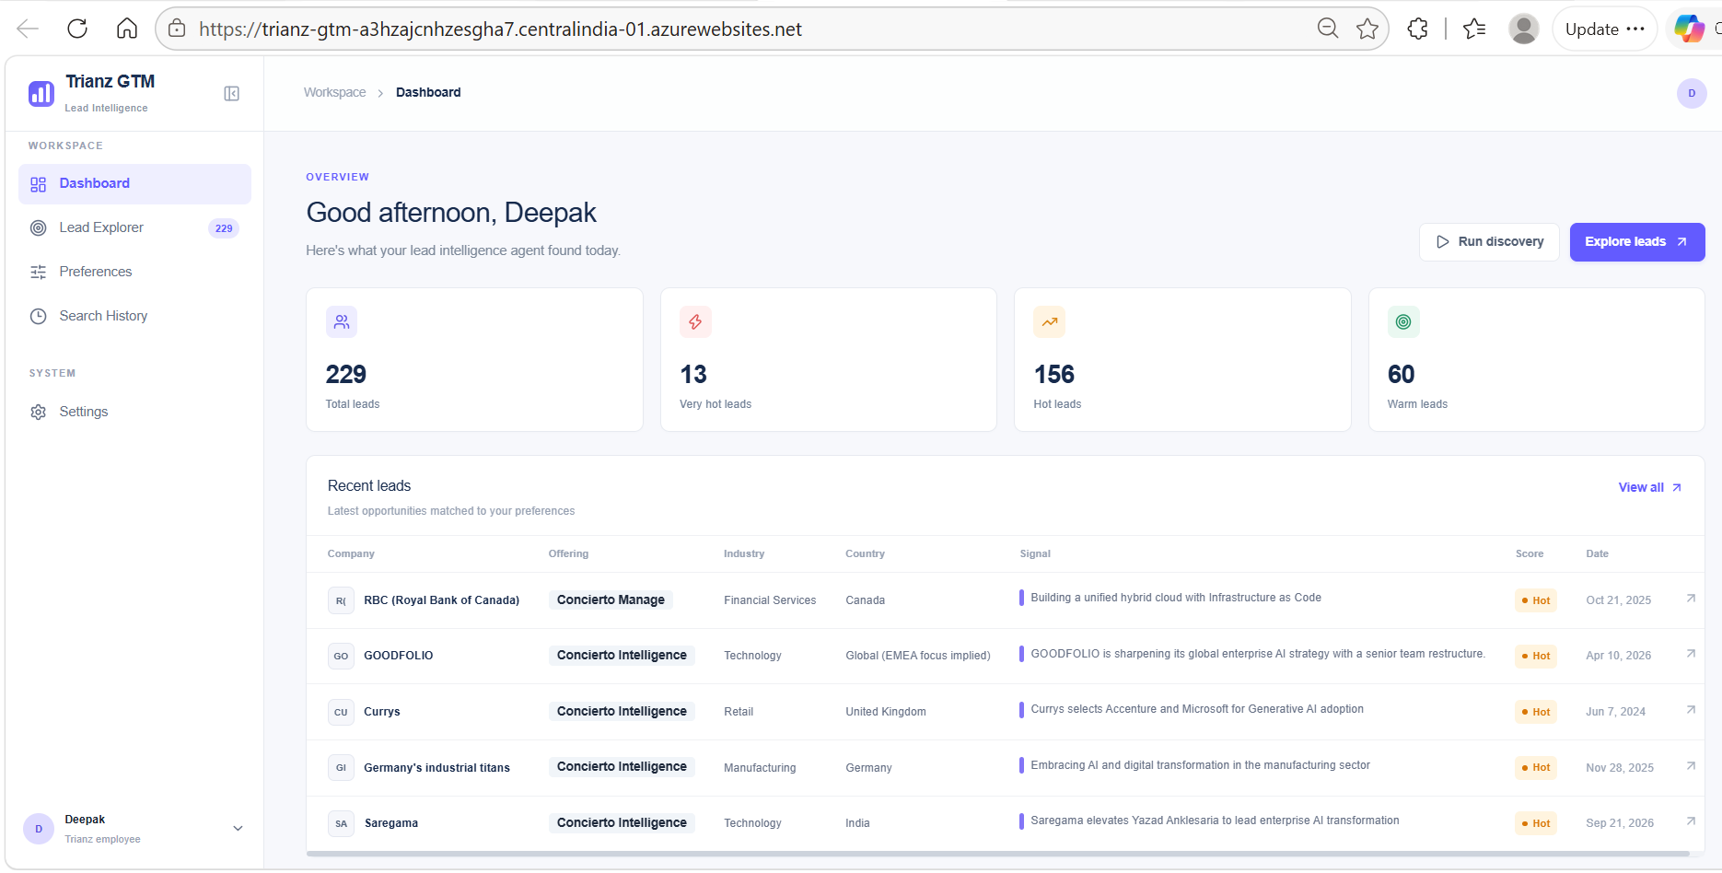
AUDIENCE  All users | VERSION  1.0 | LAST UPDATED  October 2026
Figure 1 — Dashboard overview showing total leads, scores, and recent leads list.

How It Works

The portal follows a simple four-step cycle. Understanding this flow will help you get the most out of it, whether you run discoveries manually or let the schedule handle it automatically.
1  Set Your Preferences | 2  Run Discovery | 3  Review Leads | 4  Take Action
Tell the portal what matters — regions, industries, and service areas to focus on. | The portal scans news and business signals across multiple sources to find relevant activity. | Matched signals appear on your dashboard as scored leads — ranked by opportunity strength. | Use leads to reach out, prioritise accounts, or feed into your sales process.

Step 1 — Set Your Preferences
Before the portal can find leads, it needs to know what you're looking for. You do this once in the Preferences section — choosing your target regions, industries, and service offerings. You can update these at any time.
Step 2 — Run Discovery
The portal reads public business news and announcements and uses AI to identify signals — things like a company announcing a major cloud migration, a digital transformation initiative, or a new technology investment. You can trigger this manually or set it to run on a schedule.
Step 3 — Review Leads
Each signal that matches your preferences becomes a lead on your dashboard. Leads include the company name, what signal was detected, a short summary, and a score telling you how strong the match is.
Step 4 — Take Action
Leads are not just information — they are starting points. Use them to prioritise outreach, research an account further, or share with your team. The portal keeps a history of all past runs so you can track what was found and when.

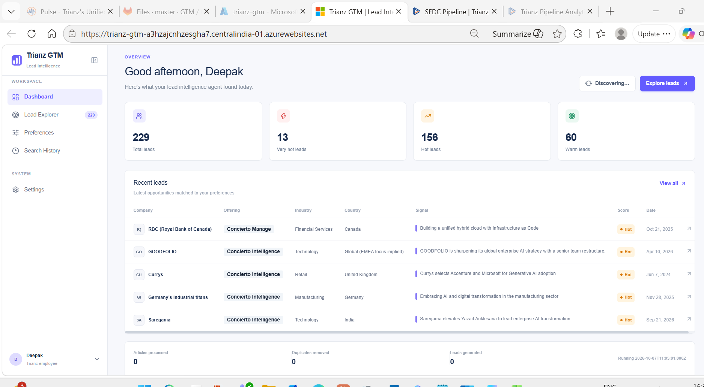
Figure 2 — Dashboard showing a discovery run in progress ("Discovering…") with live stats updating below.
Getting Started
Logging In
The portal uses your existing company account — no separate username or password is needed. Open the portal link in your browser and sign in with your usual work credentials. If you are already signed into your company account on that device, you may be taken straight to the dashboard.
TIP
The portal works best in Google Chrome or Microsoft Edge. If you run into any display issues, try refreshing the page or clearing your browser cache.
What You See on First Open
After logging in, you will land on the main dashboard. Here is a quick overview of the sections in the left navigation:
→ Dashboard — Your home screen. Shows all leads discovered so far, summary stats (total, hot, warm), and recent leads. This is where you will spend most of your time.
→ Lead Explorer — A filterable full table of all your leads. Search by company, filter by region, country, industry, offering, or score.
→ Preferences — Set your focus areas: regions, industries, and offerings. Also where you control your discovery schedule.
→ Search History — A log of all past discovery runs showing dates, articles scanned, duplicates removed, leads generated, and status.
→ Settings — Manage your account profile, workspace name, and view workspace status at a glance.

Figure 3 — The main Dashboard showing lead summary stats and the recent leads list on first open.
Using the Main Features

A · SETTING YOUR PREFERENCES
Preferences tell the portal what kind of leads to look for. Set these up before running your first discovery.
1. Click Preferences in the left navigation.
2. Under Region, select the geographic areas you want to monitor — for example, APAC, EMEA, or North America.
3. Under Industry, choose the sectors relevant to your work — such as Manufacturing, Financial Services, or Healthcare.
4. Under Offering, pick the service areas you want to match leads against.
5. Add a Notification email if you want to receive an alert when a discovery run completes.
6. Set your Schedule time and choose how often the discovery should run (Daily, Weekly, or Biweekly).
7. Click Save Preferences. Your settings are saved immediately.

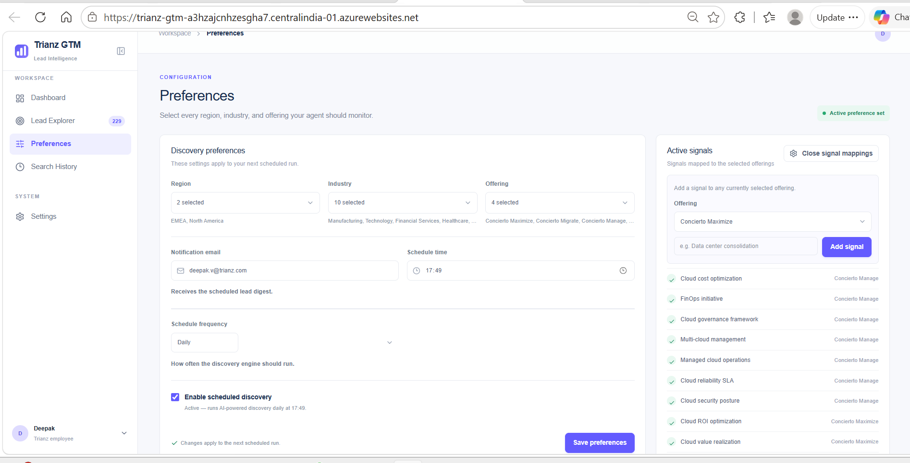
Figure 4 — The Preferences page showing Region, Industry, Offering selections, notification email, schedule time, and frequency options.
B · RUNNING A MANUAL DISCOVERY
You can trigger a discovery at any time — useful when you want fresh results right now.
1. Go to the Dashboard.
2. Click Run Discovery in the top right.
3. The button changes to "Discovering…" while the portal scans for signals. This usually takes one to two minutes.
4. When complete, new leads appear on the dashboard and the stats update automatically.
C · READING YOUR LEADS
Leads appear in two places — the Dashboard (recent leads) and the Lead Explorer (full filterable list). Click any lead row to open its full detail view.
→ Company & Initials — The organisation where the signal was detected.
→ Offering — Which Trianz service area this lead maps to.
→ Industry & Country — Sector and location of the company.
→ Signal — The specific business activity detected (e.g. "Cloud Migration", "Digital Transformation").
→ Score — Hot = strong match · Warm = partial match · shown as a coloured badge.
→ Lead detail view — Click any row to see the AI-generated reason, extracted insights, project stage, business impact, and the original source article.

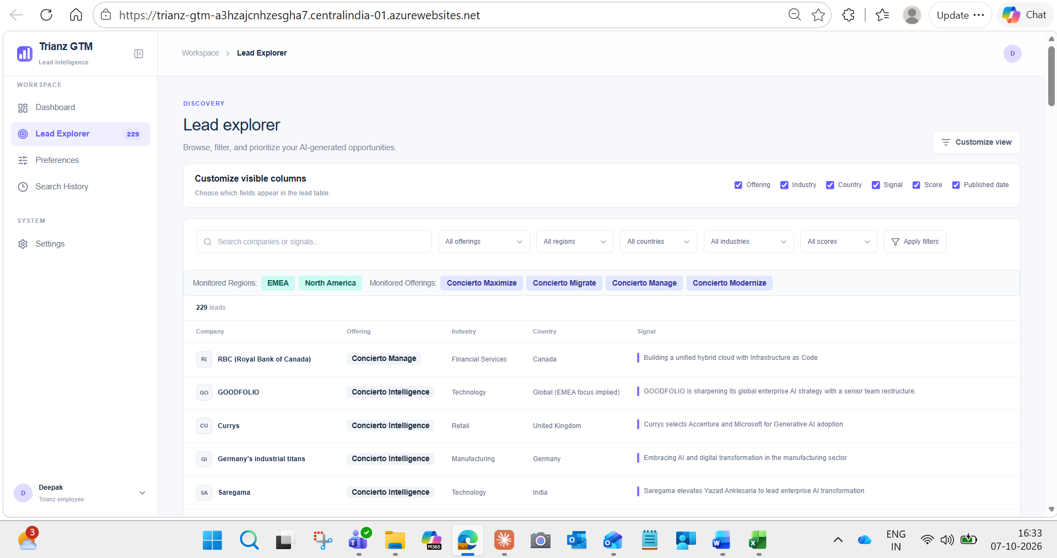
Figure 5 — Lead Explorer with filters and AI Intelligence panel expanded.
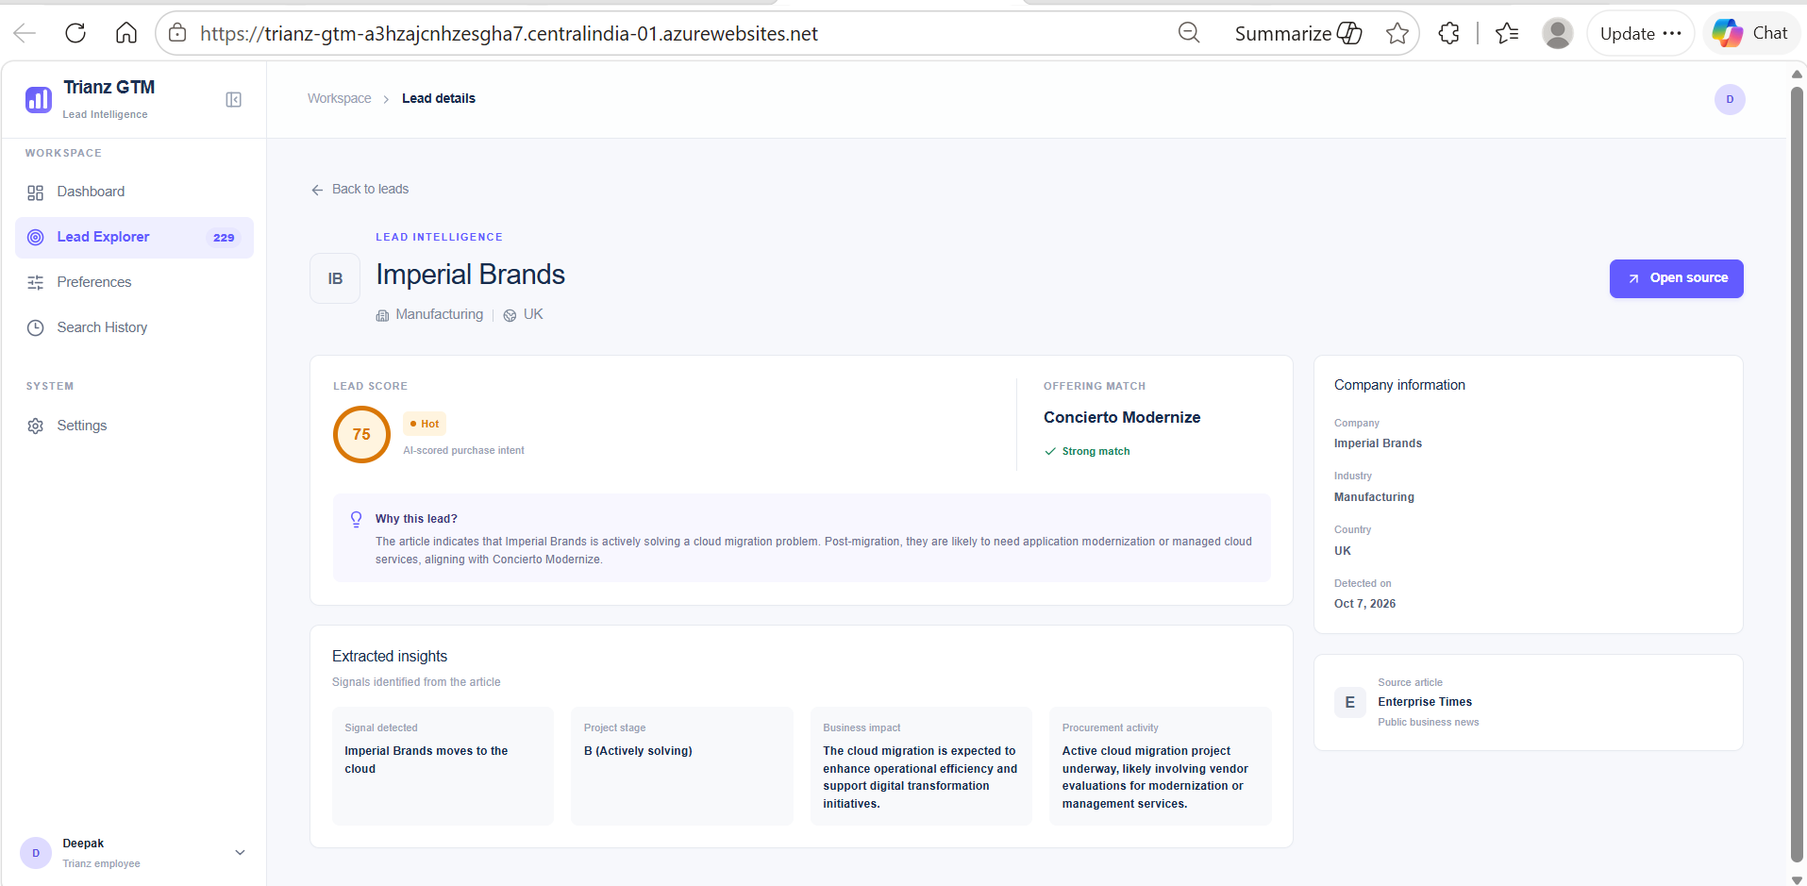
Figure 6 — Lead detail view showing score, offering match, and extracted insights.
D · SETTING UP AUTOMATIC DISCOVERY
Instead of running discovery manually each time, you can schedule it to run automatically.
1. Go to Preferences and scroll to Schedule frequency.
2. Toggle on Enable scheduled discovery.
3. Choose a frequency: Daily, Weekly, or Once every two weeks.
4. If Weekly or Biweekly, select the day of the week you want it to run — e.g. every Tuesday.
5. Set the Schedule time you want it to run.
6. Click Save Preferences. The schedule is now active — you will see "Active" confirmation on screen.
GOOD TO KNOW
The portal runs the schedule in the background — you do not need to be logged in or have the browser open for it to work. New leads will be waiting for you the next time you visit.
Quick Reference

Use this table to find any action in the portal at a glance.
WHAT YOU WANT TO DO | WHERE TO GO | HOW
View your leads | Dashboard | Scroll through lead cards — newest first
Explore & filter all leads | Lead Explorer | Use dropdowns to filter by offering, region, country, industry, or score
Run a discovery now | Dashboard or Search History | Click Run Discovery
Change regions / industries | Preferences | Update selections → Save Preferences
Set up a schedule | Preferences → Schedule frequency | Toggle on → choose frequency, day, time → Save
See past discovery runs | Search History | View run log with dates, article counts, and lead counts

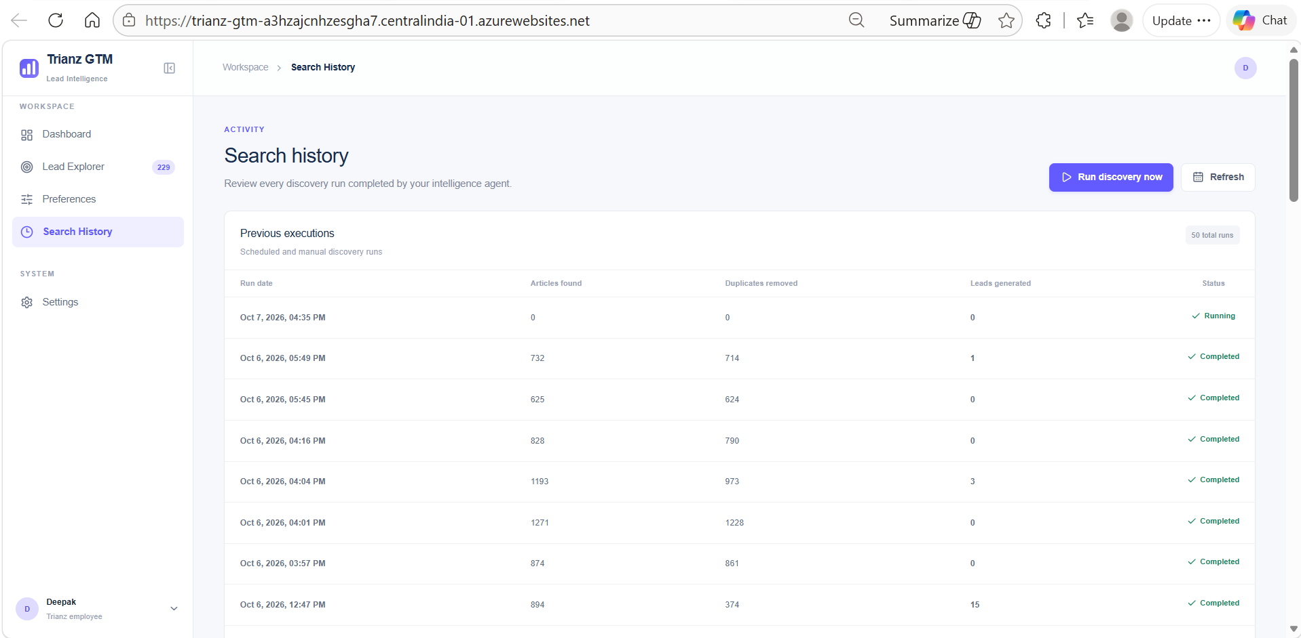
Figure 7 — Search History showing all past discovery runs with article counts, duplicates removed, leads generated, and status.

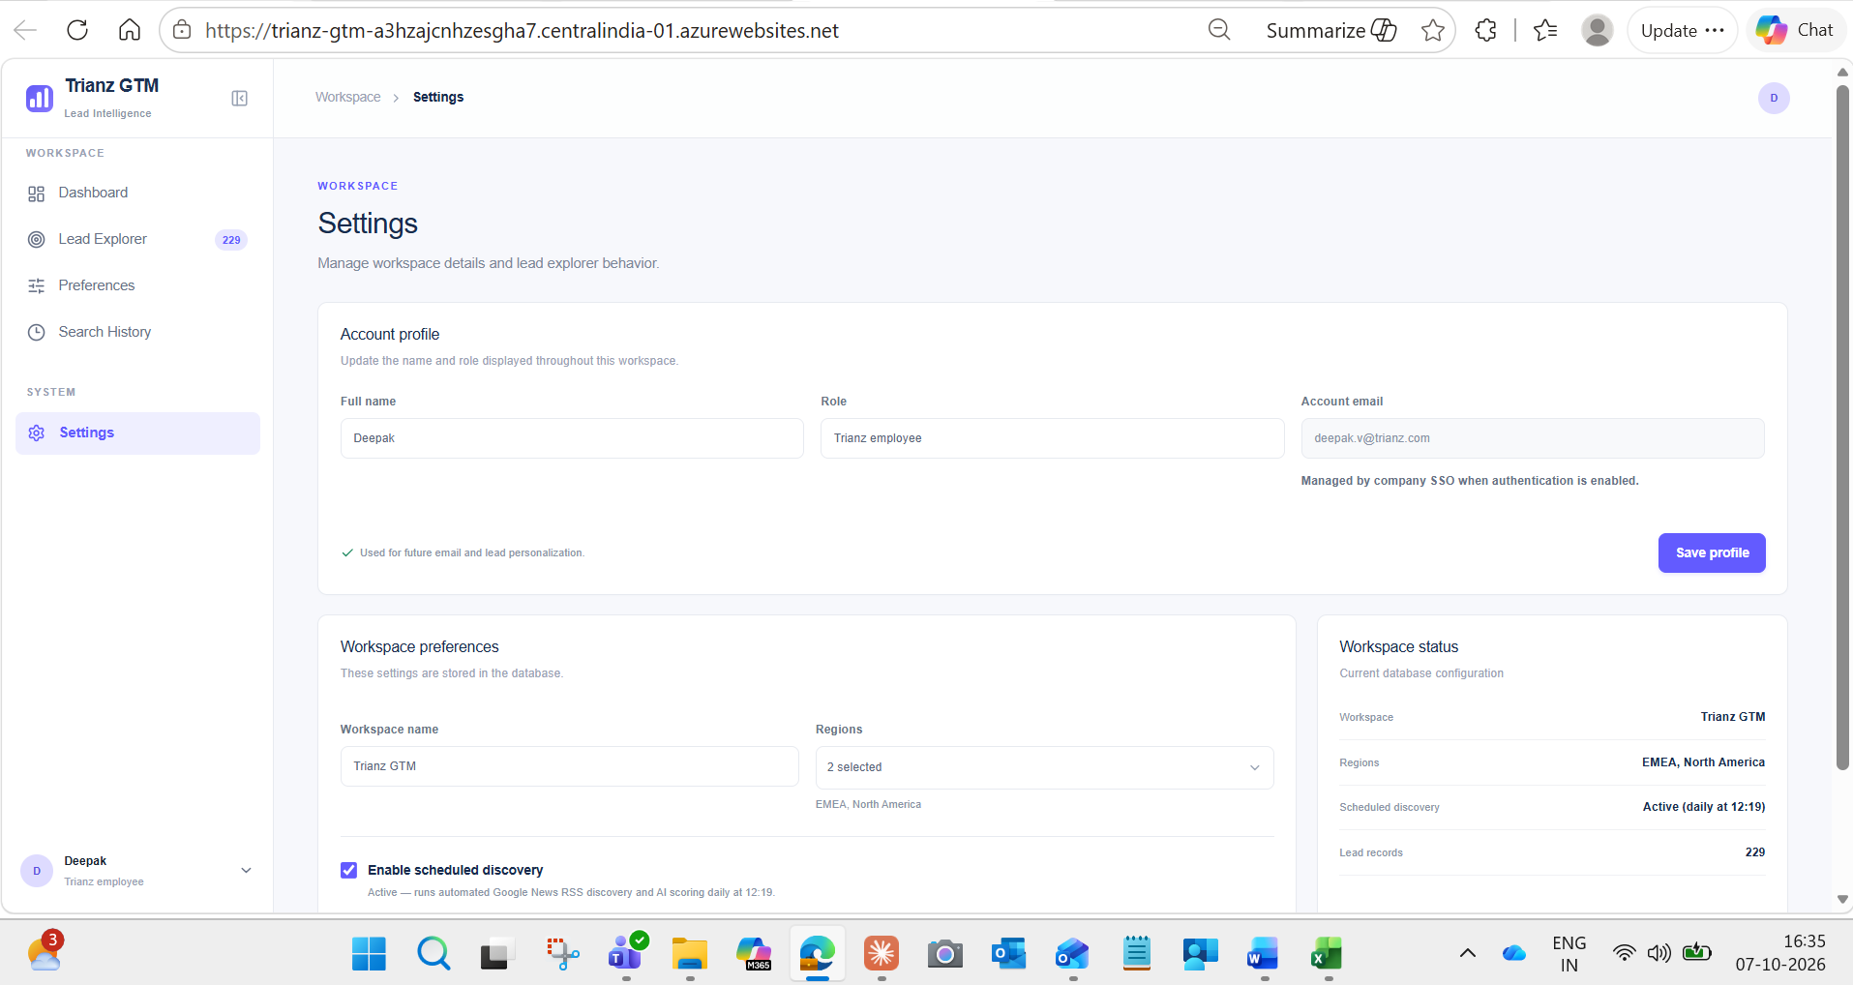
Figure 8 — Settings page showing account profile, workspace preferences, and workspace status summary.

Getting the most out of the Trianz GTM Portal comes down to three habits: keep your preferences up to date, let the schedule run in the background, and check your leads regularly. The portal is designed to do the heavy lifting for you scanning thousands of articles, filtering out the noise, and surfacing only the opportunities that matter to your work. You do not need to be technical to use it, and you do not need to check it every day. Set it up, trust the process, and use the time you save to focus on what matters most building relationships and closing deals.

